# Fusion Release Notes

## 11/?/2017 All Modules v 17.6.7

Database v 170 Changes

* Stored procedure InventoryExcessReport has been revised to ignore inventory activity types 19 (manual adj) and 30 (ABC cycle count). Parts with only these types are now considered to have no activity.

### Inventory > Inventory > View tab > No Inventory Movement Report

This report menu item, identical to the Inactive Inventory Report, has been removed.

### Prod > PAC > MO Completions

This transaction had code that checked for incomplete operations in an MO, but it always returned zero, so it never asked if it was OK to complete the MO with incomplete operations. Now it asks.

### Finance > AR > Print Customer Invoices

If you didn’t specify an end invoice number, this triggered an inconsequential SQL error, but it was adding junk to the SystemEvents table. Fixed.

### Inventory > Inventory > Change a Part Number.

This had a SQL error that resulted in some MRP references not getting changed. This has been fixed.

### Engr > Bills > Copy a Bill of Materials

This was producing an error when trying to create a BOM with an existing Part and Rev. This has been fixed.

### 96 Inv > Receiving > Purchase Order Receipt (ANDELE Problem)

Editing of lot information has been revised to not show the Create button until/unless the “Create another lot” checkbox is checked.

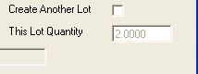 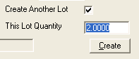

When the Create button is pressed, the Close and Create buttons are now disabled until the next lot is ready to edit.

After receiving items on a PO, the transaction returns to the screen that lists the items. If there were no more items, the Receive button remained enabled. If the user clicked it, duplicate lot and inventory activity records were created, even though no remaining items were shown on this form. Now, if there are no additional items, the Receive button disappears. Also, the message “No Items Found” is no longer displayed. That is obvious, and it is one less button to click to exit the transaction.

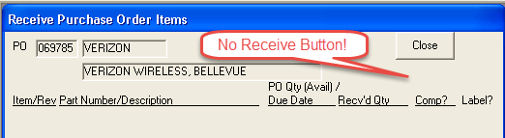

Additionally, it was noticed that the PO dropdown Included POs with unreceived items where the quantity was zero. Since the items had zero quantity, the user was presented with a blank item screen when he clicked on the Items button. These POs have been removed from the dropdown.

### 100 IMAINC BMRELEASED = 2 BOM approval/update process allowing for BMHD.BMRELEASED = 2 This should only be 0 or 1 does not allow picklist to be created

When the ENGR > Bills > Bill of Material is used to un-release a BOM, the BMRELEASED was weirdly set to 2, not zero. This has been fixed. This release sets BmhdTable.BMRELEASED = 1 in the approximately 50 cases where it was at a value of 2. Technically it should be set = 0, but we decided it was better to set the values = 1.

## 10/23/2017 All Modules v 17.6.6

Database version 169 changes:

* Column EsReportVendorStmt.Journal is added where it does not exist. This was a problem at ANDELE.

### Prod > Print MO

There was a problem that triggered an error for display of pick lists. The column EsReportPlsTable.PLSRow was incorrectly referenced as PSLRow. This has been fixed.

### Sales > Import Sales Orders

This transaction failed when SO contact names were > 20 characters. Now the name is truncated at 20 characters.

### Prod > Split an MO (Shopshf06a.frm)

This failed creating a temporary table due to non-unique name for constraint. This has been fixed.

### Inv > Revise Lots (Lotslet01a.frm)

This transaction failed when LOTUNITCOST was null. That is no longer the case.

### Sales > Packing Slips > Shipments by Shipping Date Report (PackPSp05a.frm)

IMAINC had a problem with this report when it included the 10/17/2017 date. I could not determine what the exact cause was, but examining the logic, the selection clause passed to the report was extremely flawed, requiring a lot of unnecessary processing. The report now works for 10/17 with the IMAINC database, but they will need this version of Fusion.

## 10/13/2017 All Modules v 17.6.5

### AWJ Sheet Inventory Modifications

* Inventory Report. One item was missing because the width was zero. The following line of code has been removed from the data source for that report:

where

li.LOIADATE < dateadd(day,1,@AsOfDate)

and pt.PAPUNITS = 'SH'

and li.LOIQUANTITY > 0

~~and lh.LOTMATHEIGHT > 0 and lh.LOTMATWIDTH > 0~~

and (li.LOICLOSED is null or li.LOICLOSED > @AsOfDate)

and (li.LOISHEETACTTYPE is null or li.LOISHEETACTTYPE = 'RS')

and LOINUMBER = '42913-805601-74'

* Pick Restock SSRS Report. Added the ability to specify the restock date. Default is current date.
* Pick Restock SSRS Report. Added a Cancel button that makes it as if the pick never happened.
* Sheet Reservation SSRS Report. A lot location column has been added.
* Part Inventory Activity with Cost custom Crystal report admin01p_AWJ.rpt has been revised to include the user lot number.

### ANDELE Packing Slip Problem

* The Print button in Sales > Print Packing Slip has been disabled during processing to prevent it from being clicked more than once. This could potentially cause database problems.
* The Apply button in Sales > Cancel Packing Slip Printing function has been disabled during processing to prevent it from being clicked more than once. This could potentially cause database problems.
* A script has been provided to fix problems created with packing slip PS198056.

### ANDELE Custom CGS Report, fincgs_aec2.rpt

This report has been modified to produce the correct invoice total. The standard version of this report has also been corrected and checked in.

### L&E Tubing 79 Add system option to not allow log into MO op if prior op is not marked complete

Added logic to deny login if the user is trying to log in with the keyboard. If you have selected to deny login if prior operations are open and the user attempts to do so, the following is displayed.

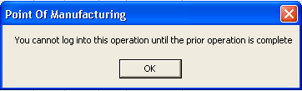

## 9/28/2017 All Modules v 17.6.4

### Database Update to v 167

Add stored procedure AddOrUpdateColumn to simplify column schema changes.

Stored procedure DeleteStoredProcedureIfExists has been added to simplify stored procedure changes.

Column ComnTable.DenyLoginIfPriorOpOpen has been added. See L&E Tubing 79 Below.

Stored procedure InventoryExcessReport has been completely rewritten. See MANSERV 87 below.

### Revised Reports

InvInactive.rpt: Inactive Inventory Report

Cclog.rpt: Cycle Count Problems List

### MANSERV 87 Inactive inventory report logic

The InventoryExcessReport stored procedure has been completely rewritten to correctly not include parts with zero quantity unless you request them. The logic is:

1. select all parts matching the request parameters

2. deselect parts that did not exist prior to the end date (i.e. no InvaTable records with earlier dates.

3. deselect parts with any inventory activity in the date range

4. determine if the part exists in the current MRP

5. if not including zero quantity parts, deselect parts with quantity zero at end date and quantity zero currently as long as those parts did not have any past-due MRP actions in the date range.

6. display all remaining parts. This report no longer shows inventory activities.

NOTE: Report InvInactive.rpt needs to be updated to work with the new stored procedure. It has been checked in to VSS. The new, more compact format looks like this:

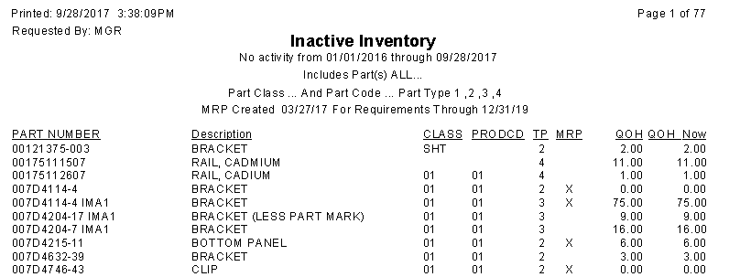

### AWJ 90 Can’t back date a PICK

This has been fixed. You can now select any date. Items will show up in inventory until the date selected.

### AWJ 91 Sheet Inventory report not showing correct data

When a rectangle was no longer active (i.e. it is picked or restocked), an indicator, LOIINACTIVE was set = 1. This eliminated that rectangle from showing up in sheet inventory. The problem was that it did not appear regardless of As Of Date. This indicator has been replaced with LOICLOSED, the date that the rectangle becomes inactive. So now, if an inventory is requested on 9/5 as of 9/1, rectangles which were still active on 9/1 will be shown. At the time this new version is installed, a line of code in the Sheet Inventory report’s dataset SQL must be changed. Old line:

and (li.LOIINACTIVE is NULL or li.LOIINACTIVE = 0)

must be replaced with:

and (li.LOICLOSED is null or li.LOICLOSED > @AsOfDate)

### COMSOL 86 Create MO from MRP Exceptions - not printing MO and PL

* This program now creates a pick list. Note: COMSOL has some very small quantities (e.g. .001 OZ). In a test, I created qty 2 of a part so the quantity required was .002 OZ. The standard pick list only shows 2 decimal places, so this ended up showing 0.00 on the pick list. Either they need a custom pick list, or the standard pick list needs to be modified.
* This program now prints the MO as well as the pick list (which didn’t get created)
* The program parameters were not getting stored correctly. Now, when you bring up the program, it remembers previous date range, buyer, etc.

### ALPHA 67 MO sales order allocations report not reporting data. Prdsh17

The report was called with a part number rather than a part reference, so part references (with dashes removed) did not match up. This has been fixed

There are 11K RnalTable records but only 344 of them match an existing SO. They all match an existing MO. This should be cleaned up.

### CASGAS 65 Cycle count log not showing part on other counts

The problem is that no lot numbers are appearing in the log.  The cclog.rpt report used an inner join and since there were no lot numbers, no rows appeared.  I changed this to a left join, so now the items appear, but without the lot numbers.  If it’s important, we can add the lot numbers but it may result in many rows for a given part in the log.

The revised report has been checked in.

### L&E Tubing 79 Add system option to not allow log into MO op if prior op is not marked complete

A new checkbox has been added to Admin > System > System Settings > Shop Floor Tab:

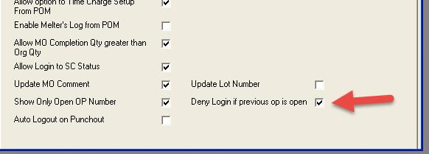

If this box is checked, a POM user cannot log into an operation unless the prior location has been closed. POM still shows the available jobs, but operations that cannot be logged on to because of this selection are shown in red:

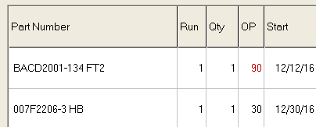

If you click on a job with a red operation number, you will be notified that you cannot log in to that operation:



Note that comment and status columns were reversed in the POM sources I had:

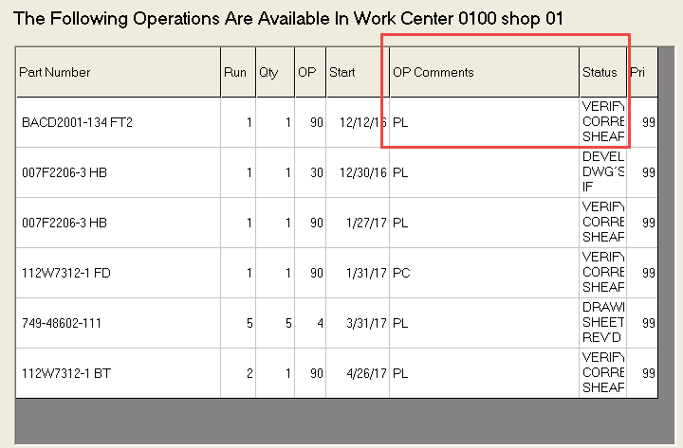

This has been fixed.

## 9/18/2017 All Modules v 17.6.3

### Database changes

An Engineering labor rates was added to the Preferences table.

An engineer indicator was added to the EmplTable table.

Stored procedure AddEngrTimeCharge has been added to create engineering time charges.

### CASGAS Engineering Labor

On the Admin > Settings > Engineering Tab, an engineering rate has been added.

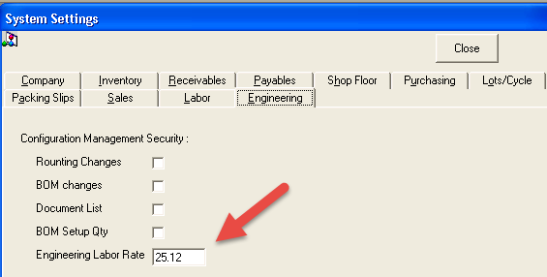

Admin > Time Mgmt > Employees now has a checkbox to indicate that an employee is an engineer:

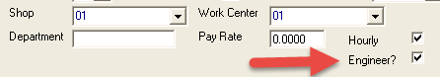

There is a new Engineering > Estimating > Enter Engineering Time Charges transaction.

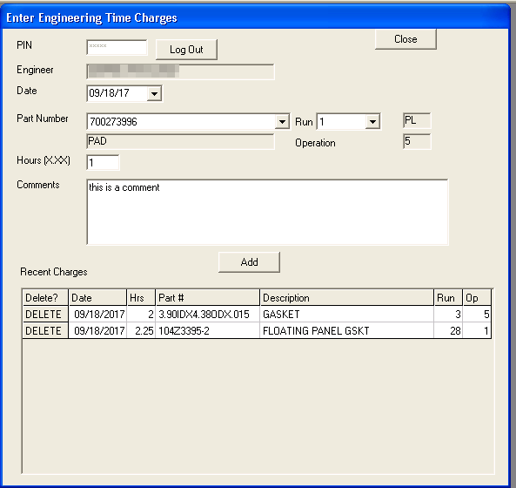

The user enters his or her PIN to log in. Only employees with the engineering bit set are able to proceed. The engineer selects a date (default is current date), a part number and a run number of a currently open MO. Next, the user enters the number of hours and a comment. Then the user clicks the Add button. The charge is added with the standard engineering rate and the user’s default account number.

The ten most recent time charges are shown at the bottom of the form. If parameters were incorrect in a time charge, press the DELETE button to remove the charge.

## 9/14/2017 All Modules v 17.6.2

See SSRSInfo Table Change in 17.6.1 Release notes below.

### Database Changes to table TlnhdTableNew

* Add “Tool Code” field (TOOL_CODE) to the right of tool class. This list would be created from user input – up to 6 alph/num digits
* Add “Unit Number”(TOOL_UNITNUM) field next to the tool code. Numeric, single digit.
* Add “Government Prime Contract” (TOOL_GOVPRIMECONTRACT) field next to the government owned check box. 20 characters alph/num with dashes.
* Change “Date Added” to “In Service Date” UI
* Add “Category” field. Drop down options 1, 2, or 3.
* Add “Last Physical Inventory” field. Date field
* All existing text columns where changed to type varchar. It drives me crazy that the char fields always show a bunch of trailing blanks that cause reports to wrap, etc. so I fixed this in this case.

### Database new table ToolCategories

This table is used to populate the custom tool category dropdown. For now, values of 1, 2, and 3 are available. If new categories are required, they can be added here.

### Changes to EsReportWIP Table

Two columns – WIPRUNQTY and WIPRUNPARTIALQTY -- were missing at least at one that caused the WIP Report to fail. They are now added if they didn’t already exist.

### MFiles now creates the working directory if it does not exist.

Could you test deleting the c:\myworkfiles directory and then create a vendor invoice to make sure I didn’t break anything? I had to make some temporary mods to test in my limited environment. I want to make sure I didn’t break anything.

### Add/Delete Custom Tool (ToolTle06a.frm)

The following new fields have been added or revised

* Add “Tool Code” field (TOOL_CODE) to the right of tool class. This list would be created from user input – up to 6 alph/num digits
* Add “Unit Number”(TOOL_UNITNUM) field next to the tool code. Numeric, single digit.
* Add “Government Prime Contract” (TOOL_GOVPRIMECONTRACT) field next to the government owned check box. 20 characters alph/num with dashes.
* Change “Date Added” to “In Service Date” UI
* Add “Category” field. Drop down options 1, 2, or 3.
* Add “Last Physical Inventory” field. Date field

### Custom Tools List (SSRS)

An SSRS report has been added that allows you to select by class and part number. Other selection options will be added after initial testing and validation of the current parameters. This report allows export of the data to an Excel XLSX spreadsheet. The spreadsheet is a template for the Import Custom Tools function described below.

### Import Custom Tools (ToolTlf04a.frm)

This function takes as input a template Excel XLSX file generated from the Custom Tools List SSRS report described above. You can edit existing tools similar to the ones you desire to import. If a tool number already exists in this template, it will not be added again. This allows you to just make corrections where there are errors and run the template again.

## 8/25/2017 All Modules v 17.6.1

This has already been deployed to CAS-SQL01. Both the MRP Actions by Part Number report and the MrpPartComments.aspx web page are currently pointed at TESTDB. We will need to update these when we go live.

### Error Logging

SQL errors are now logged for the VB GetDataSet command. SQL referencing the msdb..SysChannels table are exempt. That table is not present in most situations and that would cause thousands of unhelpful error rows in the SystemEvents table.

### SSRSInfo table change

The report server URL structure in the SSRSInfo table has been changed from:

http://XPS15/Reports_SQL2014/Pages/Report.aspx?ItemPath=/KeyMailer+Reports/MRP Actions by Part Number?User=MGR

to

http://XPS15/ReportServer_SQL2014/Pages/ReportViewer.aspx?/KeyMailer+Reports/MRP+Actions+by+Part+Number&User=MGR

The changes are made automatically during database update for this release.

The column WebUrl has been added to the SSRSInfo table. This was added for the MRP Part Comments project, where the part numbers in the MRP Actions by Part Number report are links to a page to display and edit MRP comments for that part. This column is set to http://localhost/Fusion/ by default. That will work as long as the web server and SSRS are hosted on the same server.

### SSRS Structure update. User Parameter

A User parameter is now passed through the User parameter in the URL (see above). This allows all reports to include who requested them in the header. In addition, the new MRP Part Comments web page needs to know who is making comment changes so it can include that information in the database.

An invisible User parameter must be added to all SSRS reports for a customer where this update is installed. Otherwise SSRS will error out because it does not recognize the parameter.

### CASGAS MRP Part Comments Phase 2

In this release, when you click on the part number in the MRP Actions by Part Number (SSRS) report, you are taken to a web page to view, and if desired, update the MRP comments for that part. The following selection parameters have been added:

* Part leading characters
* Buyer: One or <ALL>
* Product Code: One or <ALL>
* Part Class: One or <ALL>
* Make/Buy/Either: One or <ALL>

The following steps are necessary to implement this logic:

1. Set up an IIS web server if one is not present on the customer network. Be sure and check IIS Management Service.
2. Download and install Web Deploy 3.6
3. Add a Fusion virtual directory to the root web site. That virtual directory will be accessed as <http://ServerName/Fusion/>.
4. Install .NET Framework 4.5.1 if not present
5. Add .NET 4.5 Application Pool if not present (IIS 7 shows 4.0 but it is supposed to work)
6. Install Fusion 17.6.1. Start up a module to update the database.
7. Deploy the web project, including the MrpPartComments.aspx page to the virtual directory.
8. Make sure the web.config file FusionConnectionString is correct. Server name, database name, login (esisa) and password are required.
9. Test web page with a URL in this structure: <http://ServerName/Fusion/MrpPartComments.aspx?User=MGR&Part=062041>
10. In the Fusion database SSRSInfo table, make sure the WebUrl column has the correct server URL (e.g. <http://Server/Fusion/>).
11. Run the MRP Actions by Part Number (SSRS) report. Then click on a part number. You should be able to add, edit and delete comments for that part via the web page.

## 8/4/2017 All Modules v 17.6.0

### Database changes

* An MrpPartComments table has been created to support the creation, editing and deletion of MRP comments for particular parts.
* Stored procedure RptMRPMOQtyShortage has been revised to be identical to the version at IMAINC.

### Scripts

SPIAER.sql on the CASGAS CAS-SQL01 Administrator desktop solves the problem where packing slips, invoices, inventory activities and journal debits and credits for customer SPIAER were created for 8/30/1998 rather than 7/30/2017.

### SSRS New reports

The following new SSRS reports have be added to the CASGAS SSRS Server:

* MRP Actions by Part Number (may require more parameters and default date range)
* MRP Part Comments

### SSRS Configuration Settings

SSRS configuration muste be changed to support MRP Part Comments.

The PermissionSetName in the following two config files must be changed from “Execution” to “FullTrust” in the following two configuration files. These are the paths for SQL 2014 with an instance name of SQL2014. Your paths will vary.

C:\Program Files\Microsoft SQL Server\MSRS12.SQL2014\Reporting Services\ReportManager\

rsmgrpolicy.config

C:\Program Files\Microsoft SQL Server\MSRS12.SQL2014\Reporting Services\ReportServer\

rssrvpolicy.config

<CodeGroup

class="FirstMatchCodeGroup"

version="1"

PermissionSetName="FullTrust"

Description="This code group grants MyComputer code Execution permission. ">

<IMembershipCondition

class="ZoneMembershipCondition"

version="1"

Zone="MyComputer" />

### IE Settings for SSRS in order to launch MRP Part Comment App

* Go to IE > Internet Options > Security Tab. Make sure SSRS server is in intranet zone.
* Custom Level
* Set security level = low
* Launch applications and unsafe files: Enable

### M-Files modifications in Fusion

* When lots are created in Inventory > receiving:

1. The message “Record Successfully Indexed” is no longer displayed after a document is successfully uploaded to M-Files. Instead, the message “Record Indexing Failed” is displayed if the document did NOT successfully upload.

2. The mouseover message for the M-Files icon has changed from “Push Info to DocumentLok” to “Push Info to M-Files”.

* When vendor invoices are entered in Finance > Vendor Invoices:

1. The message “Record Successfully Indexed” is no longer displayed after a document is successfully uploaded to M-Files. Instead, the message “Record Indexing Failed” is displayed if the document did NOT successfully upload.

2. The mouseover message for the M-Files icon has changed from “Push Info to Document Imaging System” to “Push Info to M-Files”.

* When autoscan is off, FusionScan.exe is given focus. Otherwise, it is hidden.

### FileScan.exe modifications

* Code has been added to bring the main FusionScan form to the front. VB may bring itself back to the front. We will see.
* Set up so a debug version with lots of diagnosis information can be run. The output is eliminated in the Release version.
* Now you can only upload a file a single time. After a successful upload, the application shuts down.
* I temporarily added code that may hopefully will bring FusionScan to the front. We will need to remove that code later.

### CASGAS MRP Part Comments Phase 1

* This version allows creation, editing and deletion of MRP part comments. This can be done by the “MRP Part Comments” transaction in Production > MRP > Edit.
* A new report, similar to “MRP Exceptions by Part(s)” report is now available in Production > MRP > View tab. If you click on a part number in the part heading, a list of the comments, dates and authors for that part will be displayed in a separate browser page. In phase 2 of this project, the ability to edit the comments will be added in that page. The part number is shown in red for parts that have MRP comments. Currently, this report only has start date and end date parameters. Tell me what other parameters CASGAS actually uses.

### 85 COMSOL Auto Release Program not working

This program was written for Imaginetics to only release MOs where the current operation was for WC 120. The logic has been modified to only perform that check if ComnTable.CONAME includes “Imaginetics”.

Also, the version of the RptMRPMOQtyShortage stored procedure was different at IMAINC. This sp is updated to that version by this update.

### 84 AWJ Sheet Modifications

* The Sheet Restock lot dropdown now orders the lots highest lot number first.
* The form now correctly shows both part number and part description. Previously it showed part description twice.
* Requested Sheet Inventory SSRS report modifications have been made.
* Size fields now 4 decimal places
* Location included
* Part Numbers up to 28 characters are now supported
* Had to reduce font size to 8pt to make it fit.
* Sheet Reservation and Pick now shows Height and Length to 4 decimal places. Note that the location requested is already there.

### (No Item Number) Add disable comand to stop duplicate receipts

* The Receive button in the form where quantities received are entered is now disabled when clicked. It is re-enabled after the operation is complete.
* The Close button which completes the lot information entry is now disabled when it is clicked. If there is an error message requiring further action, it is re-enabled.

### Alpha Aging Prox Terms

Finap08_ALP.rpt has been revised to show Prox discount available until the nth of the month following the invoice.

### LAFEGG Custom MO Report

The tool list section has been modified. It now looks like this:

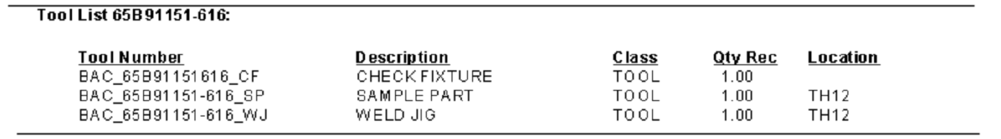

## 7/7/2017 All Modules v 17.5.9

Updates to database version 161, which:

* revises stored procedure SheetUnitCostConversion, which now sets sheet cost = unit cost * qty, rather than the cost of the sheet. This rounding difference was causing problems. All sheet lot costs are updated accordingly.
* The SheetRestock stored procedure was revised to eliminate an error in PAQOH. PAQOH’s for all sheet lots are updated to the correct sum of all lot activity.

### 66 AUSWAT During multiple lot creation have cert number default to last one entered

If instructions in the Sheet Inventory Process document are followed, this works. I.e. if three are received, don’t do three receipts of one:

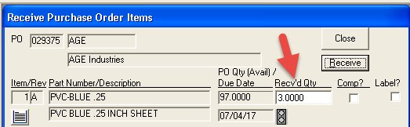

The create the lots one at a time as below:

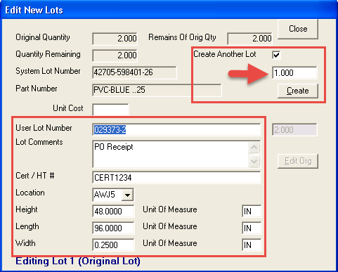

### 76 AUSWAT Add Cert/HT field to "Revise Lot"

This has been added

### 77 AUSWAT Revise lot costing rounding issue

When using "Revise a Lot", the system has a problem because the Extended Cost and Total Cost do not match (probably because of rounding) and it locks the you into a loop until you change the Matl cost.

This has been fixed and a database update automatically corrects existing sheet lot material totals.

### ## AUSWAT restock decimal places.

The Restock screen is only taking whole numbers for the length and width fields we need it to use at least 1 decimal place. We would prefer just one decimal place

Logic has been implemented to allow up to 4 decimal places. The user asked for one, but what about a quarter inch or an eighth of an inch?

### ## AUSWAT simultaneously picking multiple lots

When picking from the Pick/Reservation sheet it is only allowing one pick per entry we need the system to pick several plates per entry.  Even is we high light two items using the shift key

This transaction is using multiple selection to automatically select all rectangles from a sheet (lot) when one of the rectangles is clicked. It would be complex to allow selections from multiple lots simultaneously, so that change has not been implemented for now. It is pretty straightforward to pick multiple lots. Just enter the SO number once, click a lot, click the pick button, then click the next lot and click the pick button again.

### 75 IMAINC Script to insert next to last routing op

Implemented as script **IMAINC OP0310.sql**. All routings with an operation for WC 0310 are renumbered 10, 20, 30, etc. Next, operations for shop 01 WC 2400 are inserted prior to each WC 0310 operation as the WC 0310 operation number - 5. The new operations’ comments are set to “Package & protect parts in accordance with engineering, PO, and customer quality requirements.”

Operations are also inserted for all open manufacturing orders. RUNOPCUR is updated as appropriate. It is set to the newly inserted 2400 op if the 0310 op was previously the current operation.

### ## AUSWAT Reservation and Pick Date Selection

edit>sheet reservation and pick - needs date with auto-fill system date with the ability to override.  In case something doesn't get picked we can back date.

Done

### ## AUSWAT Report Date Printed

reports need footer of date and time printed (please use small font, right bottom corner).  Reports: Sheet Inventory and Sheet Picks

All three sheet reports have been updated and deployed at the client’s server.

## 6/25/2017 All Modules v 17.5.8

Updates to database version 160, which revises stored procedure BackLogByPartNumber.

### 76 IMAINC Remove logic that does not allow tool number to match part number.

No longer checks for existing identical part number and no longer creates a part type 8 record.

### 57 CASGAS PO info not getting updated on MO report when line is reject at On Dock Insp

This has been fixed. Note that RnopTable linkage to PO items does not include the PO release number. Release zero has always been, and still is, assumed. This should be changed, but it could involve a lot of work in many transactions.

### 64 ALPPRE Backlog by Part Number – slebl09.rpt BOOKBLp09a.frm -- report does not allow "string search" ex. 251A (Backlog by part with prices – slebl01.rpt called from BOOKBLp01a.frm --does work)

Revised to do wild card searches for parts. So, in the above example, all parts beginning with “251A” would match.

### 55 CASGAS Lots by part number report not showing comments when checked - invlt01b.rpt

The VB code has been revised to pass the comment parameter. Invlt01b.rpt did not try to display the comment. That has been fixed and checked in. The existing invlt01b_CAS.rpt custom report already referenced the lot comment field and should work correctly with the new Fusion version.

### 59 USC EDI import of 850's and 862's is inserting ship to name in the address field causing it to look duplicated

UI has been changed to say “850” instead of “830”. The code has been modified to not include the first address line, which is the ship-to-name. Hopefully, this is always the case in the EDI file. I was unable to test, so please try it and let me know.

## 6/16/2017 All Modules v 17.5.7

### CASGAS Inventory Available to Ship with Lots

This SSRS report is now available in EsiSale > Packing Slips > View > Inventory Available to Ship with Lots (SSRS)

### Azmark Mods

There were a couple of minor changes to fix issues with the Empty database (from Demo db).

## 5/16/2017 All Modules v 17.5.6

### IMAINC Add Packslip and Print Packslip from VOI

An array size limited the number of PS items to 300. This has been increased to 500 to avoid errors at IMAINC. We can program such things to dynamically allocate arrays, but this is a quick fix.

### CASGAS Tooling Module

The custom tooling transactions have been modified as below.

The custom MO remains to be fixed. Please send me a copy.

* Automatically update database table TlnhdTableNew:
* Add 20 character free-form weight field
* Remove MO# field.
* Add TOOL_NUM_REF column as the primary key.  This field will remove spaces, dashes, etc from the TOOL_NUM field.
* Automatically update database table TlitTableNew:
* Rename TOOL_NUM field to TOOL_NUM_REF.
* Remove spaces, dashes, etc from TOOL_NUM_REF field.
* Revise “Add Custom Tool” transaction
* Rename transaction to “Add/Delete Custom Tool”
* Revise logic to save TOOL_NUM_REF with creation of a new tool
* Replace MO# field with Weight field
* Add a delete button for existing tools.  Remove references from TlitTableNew when tool is deleted.
* Do not populate with first tool on startup
* Revise “Assign part to Custom Tool” to work with new TOOL_NUM_REF field
* Custom MO.  Revise to work with new TOOL_NUM_REF field.

## 5/4/2017 All Modules v 17.5.5

### ALPHA and IMAINC Vendor statements not working

The CHKACCT column was supposed to be added via a Fusion database update in 2011, but not all customers ran that code. As a result, when those customers got the most recent update, this report was blank. The code to make sure the column exists has been added in the latest update.

Update of packing slips

### ALPHA Update of packing slips blowing up

At some point in the past, a second parameter was added to the stored procedure UpdatePackingSlipCosts. The latest Fusion code requires that parameter, but evidently the stored procedure was modified manually, not via standard update code. This version makes sure the stored procedure is current, this eliminating this error.

### IMAINC Revise a lot

In certain situations (such as a lot with zero original quantity), revision of the lot blows up with a null LOTUNITCOST. This has been fixed. Null LOTUNITCOSTs are now treated as zeros. Someday we should track down exactly how the null occurs and fix it.

### Something we need to fix

If two people print an MO about the same time, the second user blows up. This is because a permanent table is truncated and then populated with an MO’s data. It happens pretty often at IMAINC.

### Something else to fix

In the POM module at IMAINC, there are a lot of errors generated with a “delete from istctable” query. We need to clean up the existing connection or create a new one prior to running this command.

## 4/27/2017 All Modules v 17.5.4

### IMAINC Work Center Queue List Stats Reports

The stored procedures for both the standard report and the history report are updated by this version. Also, the history report, prdsh21b.rpt, has been fixed.

### IMAINC Vendor Addresses with trailing blanks

Just as a precautionary measure, trailing blanks and carriage return/line feed combinations are now stripped from VEBADR and VECADR.

Also, check printing logic has been revised to remove the same trailing characters from any existing vendor address.

### IMAINC Vendor invoices creation failing

This was due to a user typing a partial date without the year (e.g. “4/15”) and then going to the Items form by pressing Ctrl-I. The control’s lost focus event normally added the year when the user pressed tab or clicked on the Items button. However, Ctrl-I never removes focus from the current field. This means that the date remained in the format “4/15”, which is not a valid SQL date. As a result, the transaction failed. However, since most Fusion transactions do not check for success of the individual SQL calls, no error was reported. The UI indicated it had succeeded when in fact, it did not.

This has been triply fixed:

1. When ctrl-I is clicked, the dates are now correctly formatted before bringing up the items form.

2. The items form now reformates the dates to make sure they are correct.

3. If, for some reason, the transaction fails, you now get an error message.

This transaction represents two flaws which exist throughout the entire Fusion system:

1. No checking for errors of SQL statements within a transaction

2. No processing of any field in a form, when the user exits by pressing Ctrl-whatever.

It would be a huge job to fix these issues globally. We just need to remain cognizant of the issues, and fix them when we have specific problems.

### Routing comment problems with single and double quotes

Double quotes (“) now stay double quotes. Apostrophes now stay apostrophes. They are doubled up in the SQL statement when they comments are saved, but only a single apostrophe appears in the database as a result.

There are a couple of functions that perpetuated the translation of double quotes to single quotes. One is widely used and has been modified to not do that. The other one, ParseComment, has been eliminated. The following programs have been modified to no longer use it:

* Revise MO Information, Comments

## 4/13/2017 All Modules v 17.5.3

### Print MO Pick List Option

An error in the pick list option of Print MO has been fixed. This was fixed in the VB, so it should apply to all users. There may or may not be another issue with this report.

### Spurious SystemEvents messages from Revise an SO

There was substantial code attempting to track revision history for SO’s. This was incomplete and was causing lots of SystemEvents messages. That logic has been removed. PLEASE DO SOME TESTING WITH REVISE SO.

### Spurious SystemEvents messages from startup of Es2000.exe.

This code has been revised to no longer generate that message.

## 4/12/2017 All Modules v 17.5.2

### CASGAS Part list showing “Part not found or wrong type” popup.

Code was changed to deal with part type 4 count > 32768. If anyone ever get to 65536 parts, we will have to rearchitect to type leading characters into a separate textbox and only populate with those parts. Maybe we should do that anyway. This transaction must be really slow to start up.

### #49 IMAINC Completing an MO leaves open time charges on the MO

You can no longer complete an MO with open POM time charges. The employee names and the operations for the charges are displayed and the user is not allowed to continue.

### #58 IMAINC Ship packaged goods sets ITACTUAL = current date

This transaction has been revised to set the SO item ship date = the selected packing slip ship date.

### #9 IMAINC Open PO look up button next PO line time price shows for type 4, need to make it show for type 7 also

The person who requested this no longer works at Imaginetics and no one else has requested this. SKIP FOR NOW.

### #45 IMAINC Complete All Op cannot be undone

This appears to have been a problem with OPACCEPT not getting set for the operations when completed en masse. This has been fixed.

### #53 IMAINC Do not populate first MO number in the MO completion drop down field

When you start this program, it now has a blank part and run number selection.

### #52 IMAINC Complete All Ops function in MO Operations Completion should complete and stop any open time charges

This has been implemented. The user must confirm the action before proceeding. Time charges are limited to 16 hours and all time is assumed to be regular. No yield quantities are collected as they would be in POM.

### Vendor Statement

Added code to add a Journal column to the temp table underneath this report to handle the situation where the table did not previously exist. Background color went back to default after a period of time

### Modified Custom Reports to not be by module

Now you can define a custom report once for any module and it will be selected regardless of the module in use.

### Background color revision

A timer was causing the background color to revert to the normal color every minute or so. This is no longer the case.

### The Fusion version is now displayed in the MDI title bar

## 3/28/2017 All Modules v 17.4.1

### #43 IMAINC Script to add 0106 operation to all type 2 routings

As per separate document, a script, IMAINC add routing op for wc 0106, was created to renumber all type 2 routings and add an operation 10 at the beginning. The operation is for shop 01 WC 0106 and has zero hours. The script does not update MO operation, so it needs to be done when all MOs are in a status that does not require update.

More details are available in a separate Word document, **IMAINC Add initial routing op for WC 0106.docx**

### Setting of background color for alternate Fusion databases

It is now possible to set the main form background of color differently for different databases to help avoid confusion by customers when they run more than one version of a Fusion database. Simply add the following line to the ini file:

BACKGROUNDCOLORRGB=RRGGBB

RRGGBB is the hex number corresponding to the color desired. Google RGB color table to pick a color that works for you. As an example,

to set the background red:

BACKGROUNDCOLORRGB=FF0000

to set the background color back to the default, either remove the line from the ini file or set it to:

BACKGROUNDCOLORRGB=default

A pretty complete chart of color selections is at:

<http://cloford.com/resources/colours/500col.htm>

### Reports Modified

Finap02a.rpt - Vendor statement report THRSIG

Fincheck13-usc.rpt 3/19 add 5th address line USCLLC

Fingl06_new.rpt? Income statement ANDELE

THR_prdpr01.rpt Check THRSIG

## 3/11/2017 Report Corrections Checked in by Chuck

Finmocosthistorydet.rpt -- Manufacturing History – EXOTOO

Invlt01b.rpt - Lots by Part Number – CASGAS EsiInvc

Prdsha04a.rpt - Manufacturing Orders by Part Number – THRSIG EsiProd

## 3/11/2017 All Modules v 17.4.0

Upgrades database to version 155.

### IMAINC AP Invoice No PO Error Message

Not closing the GL Distribution screen can result in a **Could Not Post this Invoice. Transaction Canceled** error message on the next invoice. The calling form is now disabled until the GL Distribution screen is closed.

### SQL Error Logging

Code has been added to log most SQL Execution errors to the SystemEvents table. This will allow us to track down problems in transactions where parts of the update occasionally fail.

### CASGAS #37 Income Statement not showing total

Income statement showing net profit total for Jan 17 as $0. This works correctly with this release.

### CASGAS #38 Can’t delete contact from KeyMailer

When a row is highlighted and you type the delete key, the name cell shows “Delete <name>” and the email address is blanked out. Then, when you click save, the recipient goes away.

Prior to this revision, the only way to delete the contact was to blank out the name and click Save.

### CASGAS #39 Customer nicknames with spaces

Two customer nicknames have spaces in them, can we update all records in the db to remove the spaces?

### CASGAS #15 Can’t close pick items without pressing Items

When you’re in Pick Items, the window won’t close when you click Close. You have to press Items, then you’re able to click Close.

This has been fixed.

### USC # 42 Stop time for last shift operation past midnight wrong

Time charges for third shift not applying correctly for overnight shift - TIME>TIME>Apply shift codes - relates to latest update - logic changed?

Database version 153 revised stored procedure UpdateTimeCardTotals to provide an erroneous end time for the last operation. This is repaired in this release (database version 155).

### USC # 43 Check not showing all 4 address lines.

Custom check does not show 4 lines for the address, only 3

### ALPHA #41 Raw Material Finished Goods Report

For me, this report is working. There is a really long delay – maybe a couple of minutes – where a blank viewer page is shown while a stored procedure generates the data. I am using the JEVINT version of the finrmfg_new.rpt from 2016.

## 3/6/2017 All Modules v 17.0.3

### CASGAS Customer invoice packing slip partial failure (#16)

This transaction is now all or nothing. It now checks the success of the various SQL updates. If a ny of them fails, the transaction is rolled back and the error message “Could not post the invoice. Please try again” is displayed.

You can test this by renaming JritTable to JritTableX. Check that the error message is displayed. Rename the table back and try again to verify that the transaction now succeeds.

### CASGAS VOI does not work with SO’s past 12/25/2016 (#36)

Fixed. It now looks for 12/25 for the current year and for the next two years. SaleSLf15a.frm.

### THRSIG Invoice missing ship to country (#32)

This was because the source packing slip was missing the country. This was because the source SO was missing the default country. That has been fixed.

### EXOTOO Job Cost Detail Report (#35) finmocosthistorydet.rpt

This report was blowing up with a division by zero error for part 332A6920-5 MO 9. Somehow there is bad data surrounding this MO. One row of the result set dated 11/9 has a quantity of zero which generated the error. This data should perhaps be fixed, but it would take some time.

### THRSIG Account Balance Report (#10)

We have punted on this report request to show totals for a date range rather than from the beginning of time. This would be a new custom report.

### THRSIG Account Balance Report (#11)

Entering the end date (balance as of date) no longer changes the detail start date which was previously entered.

### THRSIG Vendor Statement Report (#17) finap02a.rpt

Include manual checks

### USC Enter sales orders from an 862 EDI file

This code never found a matching price book entry, then tried, and failed, to get the sell price from the part table. These two problems have been fixed.

### Detail Payable Aging Report for Alpha (#33) finap08b_ALP.rpt

There were two problems with this report:

1. The calculation for standard discount available for vendors where net days was set = 0 showed an available discount if the invoice date was the date for which the aging was being calculated. Now the discount days must be nonzero for this discount to calculate.

2. Somehow the old report, without prox fixes, got distributed to the customer. This report includes the correct prox ligic.

### THRSIG Account balance report (#10)

The user request for showing debits and credits in a date range is a totally separate report. We put this request on hold but can quote a price for the report if it is still desired.

### THRSIG Vendor Statements (#17) finap02a.rpt + underlying VB code

The data for this report (in the executable) has been revised to ALWAYS include manual checks. For manual check memo is shown as invoice number and check post date is shown as invoice date. It is assumed that for manual checks there will be only one invoice, i.e. one credit to the check cash account.

### THRSIG Add check date to PO form (#19) THR_prdpr01.rpt

The check actual date has been added:

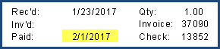

### THRSIG Computer Check Creation (#20)

Computer check creation-Have the total amt of the check run on the print screen with the # of checks & starting check number. Done.

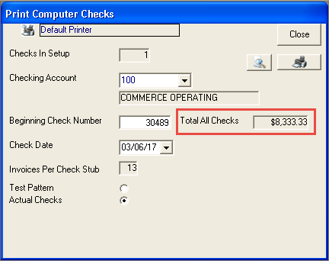

## 2/6/2017 All Modules v 17.0.2

Note: if you have been testing with a database, Version.Version = 154. Set it to 153 and then start Fusion to get the latest Sheet Management stored procedures.

### Finance > AP > 1099s Report (#31)

This report has been modified to select checks to include in the 1099s based upon post dates rather than check actual dates.

### Finance > AP > Detail Payable Aging Report for Alpha (#33)

There was a problem with prox terms for months with less days than the invoice month (i.e. Feb with 28 days following Jan with 31 days. This has been fixed in the custom Alpha report finap08b_ALP.rpt. This is the report that is called when details are selected. If only a summary is requested, Finap08a.rpt (the standard version) is called.

### Sheet Management (Inventory Module)

* SSRS viewer now pops up in front of Main MDI form.
* You are now able to update the lot location when restocking a sheet.
* You are now able to update lot comments when restocking a sheet
* The inventory report now includes the user and the date a restock or PO receipt activity occurs.

## 1/19/2017 All Modules v 17.0.1

### Sheet Inventory processing functions have been added.

SSRS must be set up on customer server. Once the database has been updated by starting any 17.0.1 module, add a row to the SSRSInfo table with the SSRSFolderUrl set to the URL of the report folder, for instance:

http://SERVER_NAME/Reports/Pages/Report.aspx?ItemPath=/AWJ_Reports/

You may get the beginning of this URL by going to the SQL Server Reporting Services Configuration Manager and copying the Report Manager URL. Then replace “http://SERVER_NAME/Reports/ with that. Set the ItemPath field to the folder where the sheet reports are stored.

See **Sheet Inventory Process.docx** for instructions on how to use. General functionality of updated programs should be tested.

### Finance > AP > Print Computer Checks (DiaAPf03a)

Account dropdown is now disabled during print generation. It was previously possible to change the account during generation, creating database errors.

### Finance > Invoice (Packing Slip) (DiaARe02a)

When the invoice prefix was changed, the program got confused about which prefix to use. The logic for this has been improved. **Note that you still need to click the close button to complete the process for the last invoice.**

### #29 Create Sales Order from External Data (XML) (SaleSLf12a)

Exostar import of XLS reverts to max SO#, not getting last SO number. This has been fixed

### #5 Alpha AP Aging report not showing Prox discounts (finap08_alp.rpt)

Fixed on my machine. We should add this code to the Master report after we get some validation.

### CASGAS MO report problem with particular MO (CGprdsh01b.rpt)

MO 65B80254148 Run 1 had a problem when the report was viewed. Single quote mark in op 40 and field too small to show entire op comments for op 30. I enlarged field and the problem went away on my machine.

### ANDELE income statement not totaling correctly

A more recent version of this report, fingl06_new.rpt, has been provided. It works correctly in test with the ANDELE database.

### Missing AP Cash Requirements and Lost Discount Reports

These reports were never implemented and have been removed from the AP menu.

## 1/4/2017 All Modules v 17.0.0

Generated from Mohan’s sources which are now checked in to $/Fusion

Invoice from Packing Slip – After customer changed invoice type to B, couldn’t permanently change it back to I. Told Chuck to have user select I and simply close form. May get different result with different version. If that fails, edit two places in registry: HKEY_CURRENT_USER\Software\VB and VBA Program Settings\Esi2000\EsiFina\DiaARe02a and LastInvPref.

In next release fix problem where sInvPre does not change when combo box changes. Also, just store the result in one place in the registry.

### Not yet implemented

Code has been revised to log Crystal Reports errors in the SystemEvents table with Event_Procedure = “OpenCrystalReportObj”